**Quiz: Pause on a specific line**

Quiz Link: [Quiz: Pause on a specific line | Watch and Code](https://watchandcode.com/courses/350615/lectures/22913987)

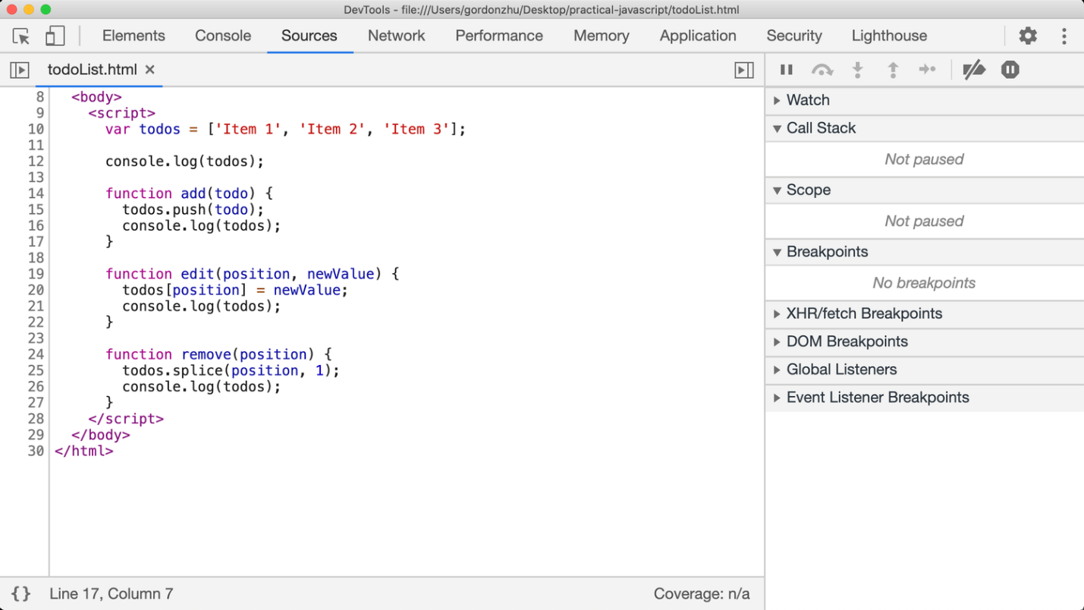

I want to pause the debugger at line 20. Which of the following series of actions will accomplish this?

1. Refresh the page
   1. False 100%, Nothing happened.
2. Refresh the page, run edit
   1. False 100%, Nothing happened.
3. Run edit
   1. False 100%,
   2. There is no pause in line 20.
4. Refresh the page, run edit, add a breakpoint at line 20
   1. False 100%,
   2. There is no pause in line 20.
5. Add a breakpoint at line 20, refresh the page
   1. False 100%,
   2. There is no pause in line 20.
6. Refresh the page, run edit, add a breakpoint at line 20, run edit
   1. True 100%,
   2. There is a pause in line 20.
7. None of the above
   1. False 100%,
   2. There is a valid answer.